Organisational profiles

Funding and public sector relationships

Contents
Introduction 3
Key findings 3
Disconnect between policy and practice 3
- Involvement of the third sector 3
- Funding is not always aligned to policy 3
- Implementation and accountability 4
The public sector has poor understanding of the third sector 4
- Lack of understanding about funding of/for the third sector 4
- Public sector needs more clarity/understanding of the ‘why’ they engage with the third sector 4
- The need for new models of engagement with third sector 4
Funding Issues 5
- Complexity of funding packages 5
- Core funding 5
- Stop/start funding and funders changing priorities 6
- Sustainability 6
- Funding relationships are short term/project specific 6
Funding relationships 7
- Trusts and Charitable funders 7
- The public sector 7
- The Scottish Government 7
- What would improve funding relationships? 8
Relationships with the public sector at the local level 8
- What type of relationships do third sector organisations want or need? 8
- What needs to change? 9
- Strategic relationships with the public sector (involving third sector in design as well as delivery) 9
- Relationships with officers 9
Relationships with the Scottish Government 9
- Clarity in purpose/expectation in relationships between Scottish Government and the third sector 10
- Scottish Government operates in silos 10
- Capacity to influence/challenge 10
- What needs to change? 10
Appendix one 12
Organisational profiles – respondent profile…………………………………………….12
Appendix two 15
- Medium and regional organisations 15
- Scottish Government funded organisations 15
- Small national organisations with predominantly self-generated income 16
Appendix three 17
- Small local organisations 17
- Organisations with a focus on delivering services 17
- Contractual/ funding relationships 17
- Influencing relationships 18

Introduction
The Scottish Council for Voluntary Services (SCVO) commissioned an independent consultant, Arrivo Consulting, to conduct depth interviews with several of our members. The aim of the project was twofold:
- To deepen our understanding of the key challenges faced by third sector organisations, specifically in relation to funding and relationships with the public sector.
- To identify common themes across the interviews that may allow for grouping of organisations by some defined characteristic, turnover, for example.
The profile of the organisations interviewed can be found in appendix one. The following two appendices outline the groupings that emerged from the research findings. The first looks at the issues specifically pertaining to funding for different groups of organisations and the second looks at the different relationship groupings to emerge.

Key findings
The interviews highlighted several recurring themes on the barriers that third sector organisations encounter in delivering their mission. These are the systemic barriers to change.
- Disconnect between policy and practice — interviews highlighted several ‘disconnects’ between national policy and the implementation of policy at the local level.
- The public sector has a poor understanding of the third sector — interviews highlighted a range of issues around the public sector’s misunderstanding and misconceptions of the third sector.

Disconnect between policy and practice
Interviews highlighted several ‘disconnects’ between national policy and the implementation of policy at the local level.
- Involvement of the third sector — In Scotland, we already have a strong policy commitment to involve the third sector in planning and delivery of services. However, the implementation of that policy at the local level is weak - and looks very different in different areas.
- Funding is not always aligned to policy — Even where there are strategic plans/policy commitments, there is often no funding to deliver the commitments. Where there are funding streams to address national policy priorities, decisions on implementation are made at the local level. There is also no consistency in what is being delivered at local level and/or how it is procured /contracted.
- Implementation and accountability — Third sector organisations felt that the local infrastructure (local authorities, Health and Social Care Partnerships, Health Boards) created barriers to implementation of policy. There is no-one to hold LA’s/HSCPs NHS to account for their actions.

The public sector has poor understanding of the third sector
Interviewees described attitudes and expectations from the public sector ‘partners’ that ranged from lack of basic knowledge about the what the sector delivers, to misconceptions about purpose and funding structures which resulted in unrealistic expectations and demands.
- Lack of understanding about funding of/for the third sector — Interviewees reported that the public sector had little understanding of the costs of delivering services. There is an assumption that because third sector organisations are charities, they must have access to other funds. This is not necessarily the case. In many cases, third sector organisations are delivering services that should be the responsibility of the public sector.
- Public sector needs more clarity/understanding of the ‘why’ they engage with the third sector — The public sector needs to be more aware of ‘purpose’ for their engagement with the third sector and design appropriate terms of engagement/relationships for the different roles that third sector plays. In some cases, the third sector is commissioned/contracted to deliver statutory services, and in others, the third sector is delivering non-statutory services. The relationships and terms of engagement for each role should be different, but are often the same.
- The need for new models of engagement with third sector — Interviewees highlighted the need for ‘new models of engagement’ between local authorities, HSCPs etc and the third sector. There have been situations where third sector organisations had worked in partnership with a local authority to develop or test an idea (for a service), the local authority then tendered the delivery of the project/service and the third sector organisation, who had often invested months of unpaid work in the development /planning of the pilot, only to lose the tender to another third sector organisation. Similarity, there are situations where third sector organisations had developed an effective service under ‘grant conditions’ then the local authority decides to tender the services – resulting in the organisation that had invested in the development of the services losing the contract for delivery.

Funding Issues
As outlined in the introduction, one aim of this piece of research was to see if it would be possible to group organisations with similar funding issues. What this research suggests is that it is the source or type of funding that connects organisations, rather than the overall size of the organisation (by turnover) as we might have anticipated. It is also clear that many funding issues are universal, regardless of the size of the organisation. For example, the challenges of holding multiple funding sources and lack of core funding are universal.
The interviews reinforced the complexity of the funding ‘packages’ on which most third sector organisations rely. The following issues were raised by small, medium, and large organisations. The exception is the group of organisations that received core funding from Scottish Government and there are also specific issues with relation to organisations that deliver commissioned or tendered services to local authorities (see appendix two).

Complexity of funding packages
Most of the organisations interviewed had multiple funders, were reliant on short term funding and therefore were in a constant cycle of fundraising. As a result, they experienced instability, and lack of ability to plan. They highlighted:
- The cost/resource required for constant fundraising.
- The cost/time in managing and reporting on multiple funds to multiple funders.
- Where organisations had multiple funders, they also held multiple relationships with funders.

Core funding
All interviewees, across all sizes and funding sources, identified the challenge of attracting core funding and highlighted funders preoccupation with funding ‘projects and activities.’ There is a concern that funders do not recognise the importance of core funding to sustaining activity and enabling growth.

Stop/start funding and funders changing priorities
Third sector organisations felt ‘at the mercy’ of funders who didn’t understand the implications of their actions (e.g., late decisions on continuation funding) or changing priorities at the delivery level.
Third sector organisations reported that funder decisions/lack of decisions resulted in:
- Leaving funding gaps.
- Third sector having to fill funding gaps from reserves or ‘close down’ services.
- Issues over sustaining employment /retaining skilled staff.

Sustainability
In the context of short-term funding and ‘packaging’ of various sources of funding, sustainability of service(s) is a challenge:
- Third sector organisations reported that they built services around availability of funding (sometimes Scottish Government/Local Authority) but when the funding sources closed, they were left with services users who continued to need the service, but no options for re-funding.
Sustainability of the organisation is a challenge. As previously noted, funders do not fund core costs – but seem to ignore the fact that third sector organisations cannot deliver ‘projects/activities’ without a central core (management/finance /IT functions).
Third sector organisations also highlighted the challenge posed by funders asking them to ‘demonstrate how they were moving toward sustainability/would make the services sustainable in the longer term’. This ‘expectation’ is unrealistic (mainstreaming of funded services by the public sector has not happened – even in the context of Scottish Government ‘challenge funds’, which were set with the expectation of mainstreaming).

Funding relationships are short term/project specific
As a result, organisations do not have relationships with funders which support strategic development of the organisation.

Funding relationships
In this section we look at third sector organisations experiences of working with different funding institutions, the main challenges they face and what needs to change to improve funding relationships with the Scottish Government.

Trusts and Charitable funders
Many third sector organisations reported ‘good relationships’ with the Trusts and Charitable funders that fund them. They recognised that these funders ‘understood the sector’ and had gone a long way to improve their processes to make them more appropriate for the third sector. However, the issue of proportionality in reporting is still a problem, with many of the smaller trusts looking for disproportionate levels of reporting.

The public sector
Funding relationships with the public sector were more challenging. Where third sector organisations had funding relationships with local authorities in particular, these were often challenging due to the fact they were so different:
- Within local authorities, the third sector had very different relationships with different departments.
- There were differences between local authorities in their contract management (levels of control) which created challenges for organisations which operate across numerous local authority areas.
For organisations that did not have funding relationships with the public sector, but who wanted them, the key issues were:
- Inaccessibility of the local authorities.
- Lack of clarity/transparency over what they funded/how to get ‘on the list’.

The Scottish Government
While third sector organisations reported generally positive relationships with the Scottish Government, they highlighted several key issues relating to quality/purpose of relationships. The quality of the relationship with the Scottish Government was often dependent on having a ‘good person’ in Scottish Government. Where the quality of relationships was less good or challenging, third sector organisations highlighted that Scottish Government staff often had gaps in skill/experience/knowledge about the third sector and therefore a lack of understanding about how their actions/decisions impacted on third sector organisation.

What would improve funding relationships?
When asked what would improve funding relationships, third sector organisations wanted more /better engagement with funders, especially the public sector. They wanted strategic relationships with public sector and funders, not just project-based relationships. They wanted relationships that were informed (about the third sector), intentional, and that recognised the added value that the third sector delivers.
For example, in the case of funding relationships with the Scottish Government. Third sector organisations suggested that ALL Scottish Government staff who have responsibility for managing a funding relationship with third sector need training to understand:
- The third sector.
- The purpose/relationship between Scottish Government and the third sector.
- The funding of the third sector.
- The implications of different funding arrangements.
- Their role as a ‘funding officer’.

Relationships with the public sector at the local level
In this section we look at what types of relationships third sector organisations want or need with local public sector institutions and what needs to change to make those relationships work better.

What type of relationships do third sector organisations want or need?
Third sector organisations described the relationships they wanted and needed at the local level as:
- Increased engagement/understanding within local authorities etc around PURPOSE – why they are funding the third sector/the added value of the third sector/how third sector helps local authorities to deliver outcomes.
- Recognition (for the added value) and parity of esteem.
- Open/honest – so we can talk about what works/doesn’t, rather than ‘contract management’ relationships.

What needs to change?
Third sector organisations recognised that ‘better relationships’ had time/resource implications for themselves, but also highlighted the need to build capacity within public sector (staff with time, understanding, values who engage with third sector) and how to embed relationships that go beyond the interpersonal.

Strategic relationships with the public sector (involving third sector in design as well as delivery)
The public sector needs to change the way it engages with the third sector.
- It needs to see the third sector as a partner in delivery (recognise how third sector contributes to its objectives) and develop relationships which enable the third sector – not act as blockages.
- Collaborative relationships, based on understanding/valuing of third sector expertise.
- Access to local authorities (in areas where they don’t have existing relationships).

Relationships with officers
Relationships with officers who are knowledgeable and who are interested in getting the best outcomes for people in Scotland, but relationships which are:
- Strategic — single point of contact at strategic level and a person who can influence/make decisions/make things happen within public sector organisations.
- Embedded rather than ‘personal’ relationships — there needs to be succession planning for strategic relationships with the third sector.

Relationships with the Scottish Government
In this section we look at some of the current issues with relationships between third sector organisations and the Scottish Government and what needs to change to improve those relationships.

Clarity in purpose/expectation in relationships between Scottish Government and the third sector
Third sector organisations reported ‘good relationships’ with Scottish Government but highlighted those positive relationships are often with a ‘person’ (and depend on personal skills/attributes) rather than a relationship with the organisation.
- That poses significant risk to the third sector.
- There is a need to clarify /codify the purpose and expectations of relationships between Scottish Government and the third sector and embed these relationships rather than relying on ‘good individuals.’

Scottish Government operates in silos
Scottish Government operates in silos – respondents felt that there is nobody with crosscutting responsibilities for third sector organisations:
- Relationships with departments often reliant on ‘good person.’
- Even where this is the case, it is difficult to navigate/negotiate between and across different departments.

Capacity to influence/challenge
Third sector organisations want to be able to influence Scottish Government policy, but many are directly/indirectly funded by Scottish Government.
There is a potential issue around the ability of the organisation to challenge Scottish Government:
- Risk to third sector organisation where there is a of perception of ‘challenging’ their funder.
- Compromises the independence of the organisation.

What needs to change?
The third sector needs strategic relationships with Scottish Government, not just funding relationships:
- A strategic role which allows organisations to influence policy, funding, and practice.
- Scottish Government needs to be better ‘joined up’ across policy areas.

The third sector must be able to challenge without risking its funding or jeopardising its independence.
There are no rules of engagement for the sector i.e., how can the third sector can challenge/influence policy without ‘biting the hand that feeds it’.
- We need to open the debate about the role of third sector in ‘challenging’ policy and practice.
- Develop a code of conduct which provides guidance for the sector and Scottish Government on the rules of engagement /how to ‘influence decision making.’

Appendix one

Organisational profiles – respondent profile
The interviews were conducted in Autumn and Winter 2021. The respondent profile of the 38 organisations in the sample can be considered in several ways. Firstly, if we look at the respondents by primary area of activity, we can see that just over half (53%) of the sample can be classified as Health and Social Care. One in five (21%) organisations fall into Community, economic and social development with the remaining 26 percent of organisations sitting across six other activity areas.
Although achieving a representative sample was not an aim of this project, it does reflect the dominance of social care organisations in the Scottish third sector. Community, economic and social development is the second largest area of activity present in the sample and is the third largest in the wider sector.
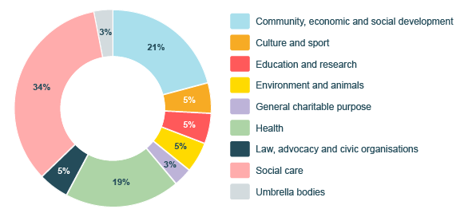
Figure one: percentage of respondents by activity area
If we look at the respondents in the sample by their latest reported annual income, exactly half are in that middle-income bracket of one hundred thousand to one million pounds per annum. A third are large organisations with an income greater than one million and one in five are small organisations earning less than one hundred thousand per annum. This is less reflective of the sector as most organisations are small. However, it more closely reflects SCVO’s membership that skews toward those middle-income organisations.
Figure two: percentage of respondents by annual income
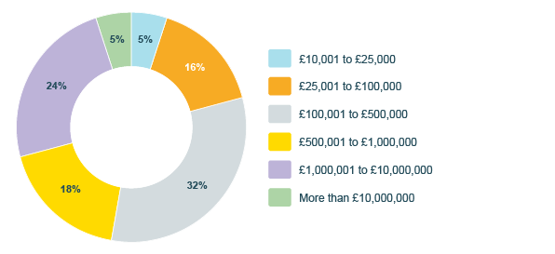
When we look at the geographic scope of the organisations in the sample, there is good coverage of organisations working at a national (39%) regional (18%) and local level (41%).
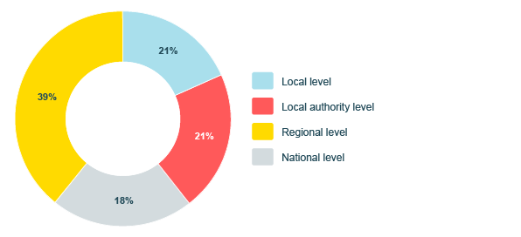
Figure three: percentage of respondents by geographic scope

Finally, if we look at the sample by geographic region, as expected, the majority (67%) of organisations have their headquarters in the central belt. This is also true of the sector as a whole.
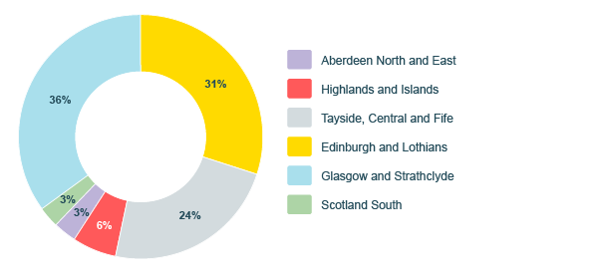
Figure four: percentage of respondents by geographic region

Appendix two

Medium and regional organisations
There were specific issues for medium scale organisations that operated across several local authority areas. As third sector organisations have expanded, they have benefited from a greater profile and recognition but,
- There is also a tension between being perceived as a regional organisation competing with local originations.
- They are managing complex funding relationships - grants/SLAs/and contracts across different areas.
- Income levels preclude them from some funding sources.
- There is a perception among funders/public sector that they ’get lots of funding’ so there is resistance to ‘more funding.’
- Lack of understanding from funders/partners that most funding for contracts/SLAs means its tied to delivery, so they can’t ‘do more’ without additional funding.
- For organisations that generate income from services (including development trusts) third sector organisations report that it was difficult to make an argument for funding for ‘charitable projects’ which will never be income generating.
- There is an assumption held by funders that you can make anything ‘income generating.’

Third sector organisations reported that grants/SLAs were often fixed and there was no mechanism for review /uplift. Organisations gave examples of grant/SLAs that had been static for 10 years.
Third sector organisations are increasingly under pressure to raise other funding to keep services going (and are in fact subsidising LA funded work).
Procurement systems/contract management and reporting systems are different in different local authority areas
Third sector organisations must manage so many different systems/ways of working /reporting etc.

Scottish Government funded organisations
We interviewed several national organisations that derived a significant proportion of their funding from Scottish Government. While these organisations benefited from core funding, there were a range of challenges.
- Core funding - but no mechanism for uplift (Several third sector organisations reported that they had no uplift in their core funding, and one had no uplift for 13 years, representing a 27% reduction in funding).
- Dependency/independence — complexity of their relationships because they are dependent on Scottish Government to be able to deliver services, but they also want to influence the services that are delivered (i.e., they want a strategic /influencing role with Scottish government).
- They need to be able to provide evidence of need/and also demonstrate where policy and practice are not working without that being seen as challenging Scottish Government, but there is potential to be seen as ‘biting the hand that feeds you.’
Funding ‘influencing’ work — While it is recognised that the third sector has a role in influencing policy (and funding priorities), these organisations highlighted the fact that they had to do a lot of work to demonstrate need/influence policy and funding
- Challenges in diversifying funding sources — the public sector wants the third sector to become less reliant - but there is a recognition in the sector that those which get core grants from Scottish Government could never raise the level of funding they need from trusts/charities.
- Funders don’t recognise the level of core funding required to facilitate development (i.e., you need developmental resources) — the levels of funding available through trusts/ charities is out of sync with third sector needs (Small trusts/charities often offer very small amounts (in relation to need).

Small national organisations with predominantly self-generated income
There was a group of small charities who generated significant levels of income via fundraising (by their members) and from trading activities.
For many of these, this was the first time they were applying for funding from public sector and trusts charities
- Didn’t have relationships with funders so weren’t on funders’ ‘radars.’
- Were unaccustomed to funders processes.
- “Found the funding world unfathomable.”

Appendix three

Small local organisations
Some small local organisations did not have or want relationships with the public sector. Any relationships with local authorities etc. were purely functional.

Organisations with a focus on delivering services
Their key relationship issues are around the need for better operational relationships.
- They need better partnerships/engagement at local level to get referrals/develop solutions.
- These organisations were less interested in strategic relationships/influencing.
- They didn’t have the time/resources and didn’t really see it as their role.
- There was a strong sense that their mission was to deliver outcomes for people – so involvement in policy/influencing ‘takes them away from core activity.’
Many highlighted the inaccessibility of the public sector. Where they did want to develop relationships, they found it hard to know how to ‘get into’ local authorities and HSCPs – at a basic level knowing who to speak to.

Contractual/ funding relationships
The challenges for medium and regional organisations that operate over several local authority areas is the number of relationships they must manage and the diversity of those relationships. Relationships reflect the culture and staff capacity of the specific local authority.
- They have relationships in several local authority/HSCPs, but these can vary in quality - in some case the third sector is treated as a partner, in others as a contractor.
- There are challenges when local authorities are not ‘joined up’ - an organisation gave an example in which the contract department in a local authority asked them for reports and the partnership organisation also asked for similar reports – so the third sector organisation ended up servicing two different departments.

Influencing relationships
Third sector organisations were involved in ‘influencing’ at the local level, through involvement in local strategy and delivery partnerships, third sector forums/etc but were always aware of need to be ‘balanced’ in challenging the public sector.
Some were also involved in local TSIs and saw the TSI as the key vehicle for interfacing/influencing the local authority/HSCP etc.
Small national organisations (single issue orgs such as Dyslexia Scotland/SMS Foundation /Zero tolerance etc) also reported that they were active in influencing through:
- Involvement in sectoral member organisations/ umbrella organisations.
- Involvement in Scottish Government Cross Party Groups etc.
A hidden cost to the third sector is the time/resource required to develop and manage multiple relationships
Third sector organisation reported that, in general, local authorities are used to /willing to work with the third sector (even if they don’t always operationalise that very well). However, many experienced significantly more challenges with health structures, the NHS, for example.

As classified by SCVO, based on the INCPO
State of the Sector: Scottish voluntary sector statistics (SCVO, 2020)

