ESS analysis of tracker funding conditions question

Background
The Scottish Third Sector Tracker has been collecting panel data from Scottish third sector organisations since summer 2021 to give current insights into the state of the sector. The tracker collects data every four months. The seventh wave took place in November 2023 and collected data from 621 organisations.

In that wave, regularly funded organisations were asked if they believed the conditions attached to their funding had become more or less demanding over the past year. Over half of respondents (55%), thought the conditions had remained about the same, but 39% thought the conditions either a little more demanding (20%) or much more demanding, 19%. Only 3% thought the conditions attached to the funding they receive less demanding than a year ago.

Respondents who thought that conditions attached to the funding they receive had become more demanding, were asked to tell us in what ways those conditions had become more demanding. This question had 152 responses.

This report by Steven Marwick from Evaluation Support Scotland (ESS) analyses 105 of those responses (see annex for exclusion reasons) and pulls out themes.

Analysis summary
- The biggest category of responses (29%) did not give detail eg “Excessive monitoring reports.” Or “Looking for more information. More monitoring.”

- A quarter said they had to do more work with the same or less (in inflationary terms) funding. Some also mentioned having to fill gaps in public services.

- Another quarter mentioned increased burdens in reporting format or frequency, more burdensome financial scrutiny or payment in arrears.

- 13% talked of new onerous terms and conditions, often related to Fair Work.

- The remainder complained about challenging communication with grant managers such as changes in monitoring demands or late notification.

- Scottish Government was referred to negatively in 16 different responses. No other funders were mentioned by name.

Overall this ESS report probably doesn’t add a lot to the overall seventh wave tracker report. However, it does provide a little more evidence of how some organisations in the sector (possibly those with public funding?) are experiencing less supportive funding relationships.

ESS coded each response, giving each a single code - see pie chart below. More detail and examples follow.

Unspecific comments
The biggest category of responses – 30 (29%) did not give detail eg “Excessive monitoring reports.” Or “Looking for more information. More monitoring.” so unfortunately don’t tell us anything useful.

However, I’ve turned the salient adjective in each response into a word cloud:
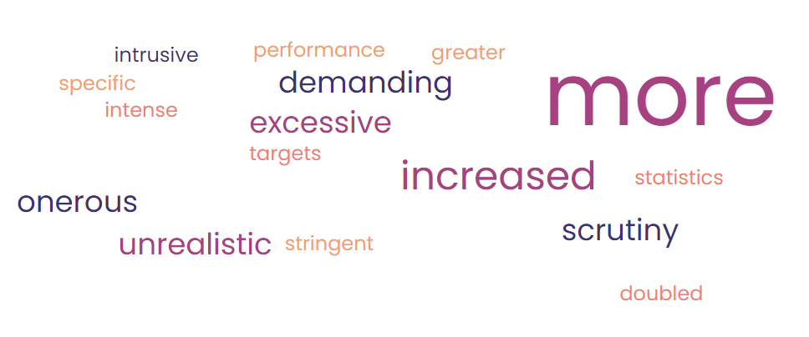

Expected to do more for less
The next most common category – 24 (23%) was respondents being expected to do more work for less money. It didn’t appear that this was an explicit change in the conditions of the funding; more that the respondent had more work to do with the same amount of funding. This response is typical of most:
“We are still expected to deliver on our objectives but with less money to do it with. Although our grant remains the same in real terms, due to cost of living increases and increased costs it equates to less.”

Some mentioned having to cover gaps in public sector services, for example:
“Everyone wants more for the same or less money. Same service delivery with no additional funding. Funded by statutory health care we are increasingly picked up gaps they can't cope with.”
“The Council expect us to take the same number of people we provide a service to but are asking us to take people who … are much more impaired … We need a higher staff ratio for each person because of their erratic or sometimes violent behaviour.”

Format and frequency of reporting
14 respondents (13%) talked about more demands in relation the format or frequency of reporting of reporting, for example:
- More onerous online reporting
- Quarterly reporting when it had been annual or six monthly
- Disproportionate amount of reporting for small grants

Illustrative quotes (my bolding):
“Reporting has been somewhat more onerous partly due to online reporting and so you need to complete off line and then cut and paste into online forms and forced to adhere to word counts etc”
“It’s now monitored quarterly rather than annually.”
“Looking for quarterly reviews, instead of annual. They have reduced our payments. More work, for less money.”
“NHS funding for £500 requesting a 9 page report at the end of it. The money only paid for materials so we wouldn't expect the staff time needed for this. Reporting requirements also changed after it was awarded, its moving the goalposts”

One respondent compared the current situation with pandemic experiences:
“we have one funder who gave £6,000 but we have to do quarterly reports on activities delivered. … I think everything has reverted to pre pandemic behaviours but with bells on, it is actually worse now even though the 3rd sector proved its worth with no arguments through the pandemic experience.”

Financial reporting
10 (10%) of respondents mentioned more financial scrutiny. For example:
“More checks on how money is being used”
“Over the past few months, there has been a noticeable increase in the requirements related to financial accountability and cost management. This includes providing detailed reports on how funds are allocated, with a stronger emphasis on efficient use of resources.”

3 further respondents said that there had been a move to payment in arrears with consequential challenges for cash flow.

Challenging terms and conditions
13 (12%) responses mentioned more challenging terms and conditions in relation to internal policies and procedures. The most common example is respondents having to evidence that they are adhering to Fair Work, sometimes at the same time as funding conditions make doing so even harder.

Illustrative quotes (my bolding):
“The Fair Work conditions introduced by one of our SG funding sponsors have meant extra work - e.g. having to nominate a staff rep for a team of 5 staff and having to sign up to conditions that say our funding cannot be used to meet any employer obligations such as sick pay.”
“the "evidence" Scottish Government required for us to "prove" our commitment to Fair Work was over burdensome, and felt meaningless. Also, despite the living wage increasing, funding is not provided for us to meet these increases, which means less staff and less services.”
“In the grant, they are now saying, they will not cover staff absence, maternity leave or holidays.”
“requirement to further evidence … GDPR and data sharing requirements”

Challenges in communication
The final categories relate to more burdensome or challenging communication with grant managers (4 respondents) and late notification (7 respondents).
Illustrative quotes
“Monitoring requirements frequently change or are inappropriate for the services we are funded to deliver, and requests can come with very short notice.”
“it would be good to know what they actually do with this [our reports] as it's so important for us to be able to learn the strength of such”
“We continually get passed to different organisations to administer our funding which requires huge changes in reporting styles and outcomes we have to meet.”
“Late decisions on grant making have condensed the time to deliver the outcomes - this leads to issues on recruitment e.g. short term posts etc.”
“We're being asked to increase our own capacity … without surety of increased levels of funding. Actions should happen now but we won't know if funds have indeed increased until February (or March as it was last year). We would also benefit greatly from multiyear funding.”
Annex: responses that were excluded (reducing 152 to 105)
- 9 responses that were not about funding (for example, increased pressure on service delivery, governance challenges)
- 19 responses about increased burden in applying for funding
- 4 responses about increased competition in applying for funding
- 15 responses about funding cuts – such as funders that used to fund them no longer doing so
We can’t assume that the respondents’ conditions for existing funding are not more demanding; it’s just that the text of their response was not about such conditions.

Evaluation Support Scotland
www.evaluationsupportscotland.org.uk

Registered Company SC284842 Scottish Charity SC036529
5 Rose Street, Edinburgh EH4 5BZ
info@evaluationsupportscotland.org.uk

The Tracker is run by SCVO with funding from Scottish Government, William Grant Foundation and The National Lottery Community Fund. Please click here for more.

