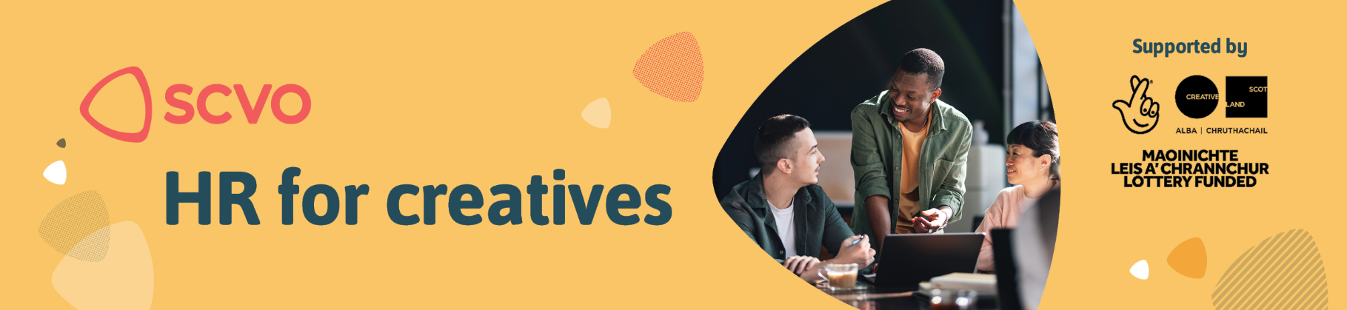

Application form

Thank you for your interest in HR for Creatives. If you have any questions about the application process, or if you have access requirements, please contact hrservice@scvo.scot

Please complete all sections below, save the document, and return your application by email to hrservice@scvo.scot

The closing date for receipt of applications is Monday 16 February by 12 noon.

Organisation name
Key personnel participating in the project.
Please list up to two individuals who will be directly involved in the project, including their role titles:
Describe what your organisation does.
Focus on your mission, the communities you serve, and any recent achievements. Please answer in up to 300 words.

Tell us who currently ‘does HR’ in your organisation?
For example, who drafts contracts and HR documents, who is responsible for keeping HR records such as annual leave. Please answer in up to 250 words.

What are the main HR challenges you are experiencing or expect to experience within the next 12 months?
For example, have you identified areas where your organisation needs HR support? In which areas do you think your HR practice is strong? Please answer in up to 500 words.

Tell us what difference the support will make to your organisation.
For example, in your answer you may wish to describe your HR ambitions, what you hope to learn, and the difference the support will make. Please answer in up to 500 words.

Organisation size
Please tell us about your core team size, how many people you employ including the full time equivalent (FTE), how many freelancers you work with, and how many volunteers. If this varies throughout the year, you can include this in your answer.

What area do you serve?

Select an area

If other or more than one area, please specify:

Artform or creative practice

Select an art form or creative practice

If other or more than one artform or practice, please specify

Are you subsidised?

Select an item from this list

If other, please specify

What is your legal structure?

Select an item from this list

If other, please state

Thank you for your interest in HR for Creatives.
Please save this application form and return by email to
hrservice@scvo.scot

Privacy notice – HR for Creatives application form
To process your application, we will collect and store the information you provide above. As part of the programme evaluation, your application details will also be shared with our research partner, CG Research and with Creative Scotland. Your data will be handled in accordance with UK GDPR and will only be used for the purposes of assessing your application and evaluating the programme. We will retain your application for 12 months after the programme ends. You have the right to access, correct, or request deletion of your data at any time by contacting hrservice@scvo.scot
Who we are
The Scottish Council for Voluntary Organisations (SCVO) is a Scottish Charitable Incorporated Organisation. We are a charity registered in Scotland SC003558. Our registered office is Caledonian Exchange, 19 Canning Street, Edinburgh, EH3 8EG.
How to contact us
You can write to us at the address above or contact us by email or phone at: HRService@scvo.scot or 0800 169 0022

